|  |  |  |
| --- | --- | --- |
|  | | |
| Game Design Document | | |
|  | | |
| Eldritch Fruit Beat ‘Em Up | | |
|  | | |
|  | | |
|  | | |
| By Capybara Studios | | |
| Andre Borja  Eduardo Cavalcante  Naomi Freire  Sebastian Beltran | | |
|  | | |
|  | | |
|  | Contents  Overview 2  Description 2  Goals 2  Pillars 2  Hook 2  3 Cs 2  Character 2  Camera 2  Controls 2  Features 3  Enemies 3  Strawbat 3  wizvocado 3  Barricades 3  Acid Pools 3  Hearts 3  Production 4  Kanban Board 4  Team Members and Responsibilities 4  Risks and Mitigation 4  Publishing 4  Art 4  Tech 5  Audio 5  UI 5  Post-mortem 5  What went wrong 5  What went right 5  What we learned 5 |  |

# Overview

## Description

Top-down beat ‘em up game where all characters are living fruit that takes place in a trash dump.

## Goals

The main design goal of this game was to elaborate on the potential of the Atari Controller constraints in combat. We approached the project with the ideal of having more than one melee attack with the one button. That was achieved by implementing a three-attack combo in which each attack affects a different area around the character.

## Pillars

1. Combat – the main focus of the game is combat, whereas the only button aside from the directionals is the SPACE bar for melee attacks. We focused on developing combos for this one button and making the gameplay diverse with the constraint.
2. Enemies – in the prototype for this game, there are two enemies with entirely different behaviors. This is one of the core elements sought out when designing the game: having varied enemies and eventually also bosses that somewhat mirror the smaller enemies’ behaviors.
3. Theme – the theme of the game is cartoony Eldritch horror with fruits. Everything in the design and visuals is tied to the theme.

## Hook

Beat ‘em up game with living fruit that uses the input constraints of an Atari controller.

# Logo Description automatically generated3 Cs

## Character

The main character is the Bananapus! A banana peel that has come back to life due to a cosmic strike in the trash dump. Her goal is to escape the trash dump and avoid going to the landfill.

## Camera

This is a 2D top-down game.

## Controls

Her controls are based on the constraints of an Atari controller: one joystick and one button. The Banana Peel moves in all four directions in the game pad and performs combat actions with the button. Double-tapping on any of the arrows makes the Banana Peel dash in that direction.

The button that was chosen aside from the directionals is the SPACE bar. It is tied to the banana’s melee attack. A single tap on the button is a light attack one unit below the character onscreen. If done so a short period after the first, the second tap does more damage and affects one unit above the character. The third tap finishes the attack combo and affects all directions around the banana.

# Features

## Enemies

### A picture containing text Description automatically generatedStrawbat

The Strawbat is a strawberry with a bat soul. It is a mindless creature whose only instinct is to bite chunks off of other fruits. They move around in swarms and bite the player, giving him damage.

### wizvocado

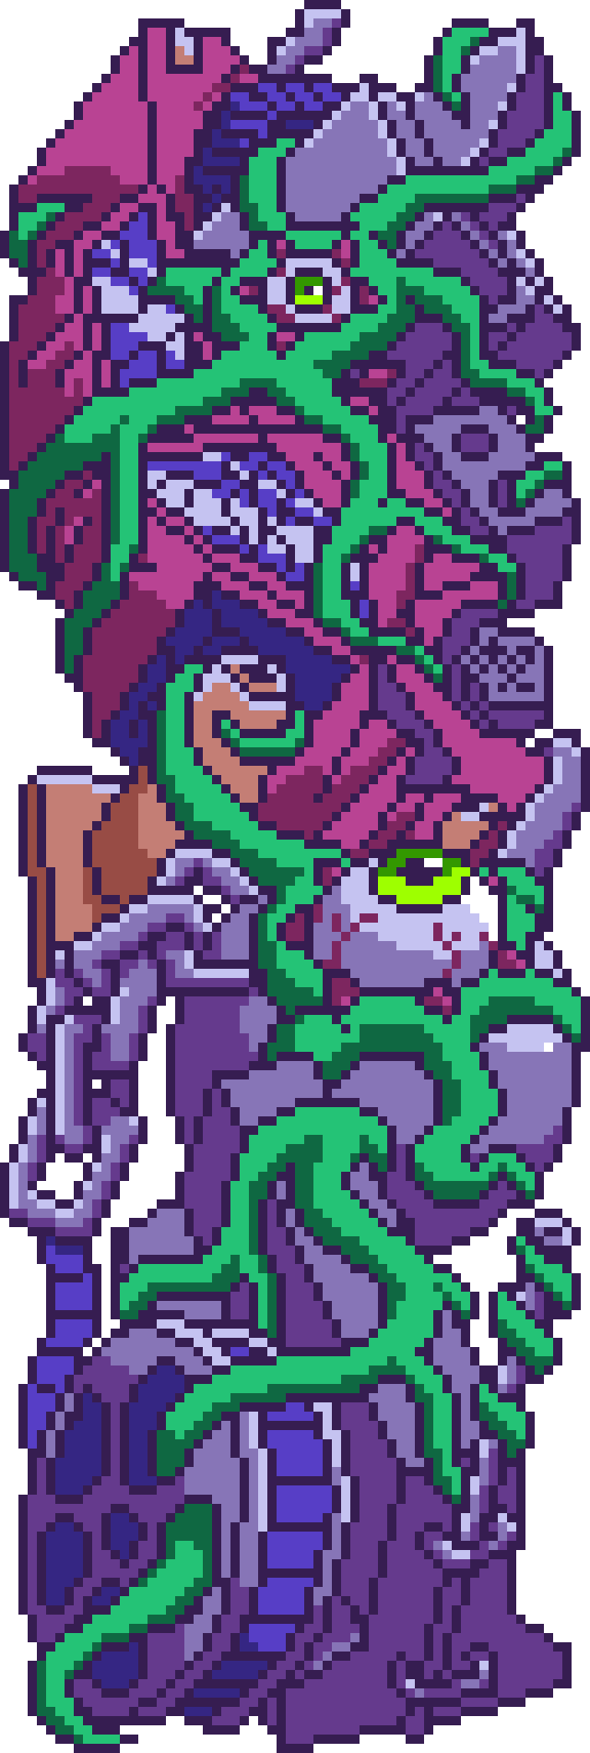The Wizvocado is an avocado that is being possessed by a worm. The worm has its tail stuffed from the back of the avocado and out through the center beneath the seed. The worm controls the avocado and uses his eye staff to cast new seeds in the avocado to shoot at the enemy. His eyes recognize the player’s position and shoot in a straight line towards them.

## Barricades

The barricades are blockages made by the fruit to keep the Bananapus from leaving the Dump. They can only be destroyed by killing a large amount of enemies in each area.

## Acid Pools

The acid pools are harmful to the Bananapus and will damage her on collision.

## Hearts

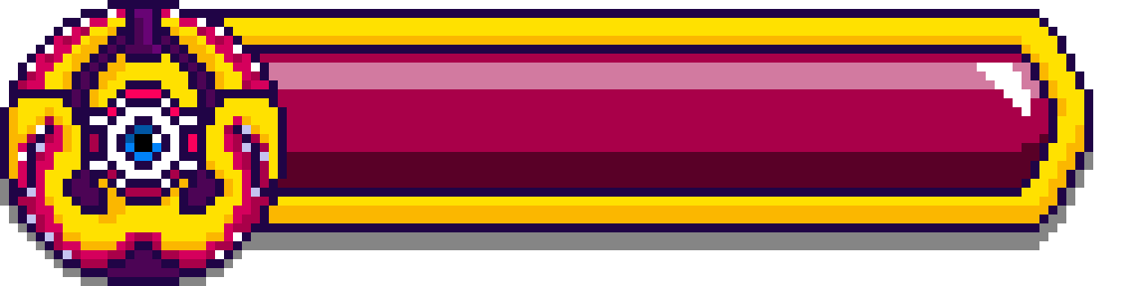The hearts restore Bananapus’s health. They are hidden inside destructible boxes around the level.

# Production

## Kanban Board

<https://trello.com/b/blDKxEn1/bananapus>

## Team Members and Responsibilities

|  |  |
| --- | --- |
| Team Member | Main Responsibilities |
| Andre Borja | Programmer |
| Eduardo Cavalcante | Level Designer |
| Naomi Freire | Project Manager, 2D Artist |
| Sebastian Beltran | 2D Artist |

## Risks and Mitigation

Identify any risks and their possible mitigations. Add more rows as needed. Check example below.

|  |  |
| --- | --- |
| Risk | Mitigation(s) |
| Team has never made a beat ‘em up game | Prioritize combat and enemy AI implementation |
| Atari controller is wider than a single button but also restrictive | Explore what can be done to augment the power of the few buttons available |

## Publishing

<https://naomifreire.itch.io/bananapus>

# Art

Lovecraftian horror in pixel-art cartoon form.

<https://br.pinterest.com/nanahfreire/bananapus/>

# Tech

Unity Engine with the following plug-ins: Text Mesh Pro (TMP), 2D Tilemap Extras, Cinemachine, Astar Path Finding.

# Audio

Energetic rock music with goofy tones.

# UI

The UI is very minimal, dark with some flashiness to match with the vibe of the game.

# Post-mortem

## What went wrong

* It took too long for us to decide on a concept, something that could’ve unlocked the workflow for the art team.
* Scripts were based on research and testing and were stitched together in order to make things work. In the future, they should be better organized and accessible to other team members so that anyone can come in and help out with what is necessary (for example: adding animations, changing sprites, adding sounds).
* We didn’t decide on the essence of the game. We kept thinking of all the possibilities of use with the Atari input system and the gameplay ended up lacking a specified design goal.
* The step-by-step workflow wasn’t specified since the beginning. This generated a lot of loose ends for the process that were only tied due to the constant attention by members of the team.

## What went right

* We aligned a concept that was fun to design and elaborate on.
* We paid a lot of attention to visual details.
* Team worked very well together in sharing information and tasks where necessary.

## What we learned

* Art team learned to work with pixel art.
* Accessibility should always be a priority in teamwork.
* We would’ve had time to develop a boss fight.